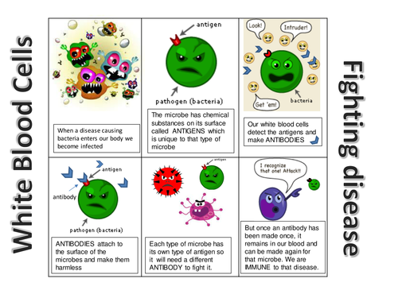
Immune System
Comic Strip Project

Objective:
Students will utilize their notes and class discussions to illustrate the steps of the immune
system on a comic strip.

Organization:
1. Fold your paper 1 time hot dog style and 2 times hamburger style to make a sheet of paper with 8 sections.
2. Consult your notes and label each section in order based on the notes from class.
3. Illustrate each step how you feel it best represents that phase.
4. Label each section at the top with each of the 8 phases of the immune system.

Comic Strip Requirements:
1. 8 sections, numbered and in order with titles and borders.
2. Each section should have an illustration of each phase with color.
3. The Comic should have a minimum of 8 speech/thought bubbles (one per section).

Category | 5 = Above  Expectations | 4 = On Expectation | 3 = Needs Work | 2 = Little to no effort | Multiply by  (X) | Points
Titles and Borders | Title for every section. Borders are clean. | Titles for every section. Sloppy borders. | A Few titles present. Sloppy or no borders. | No titles, no borders. | 5
Color and Overall Neatness | Very neat and clean. | Slight smudges with colors but overall nice appearance. | Sloppy coloring, not very neat. | No color. | 5
Mechanics | Grammar, spelling, punctuation and capitalization are correct. No errors in the text. | 1-2 grammatical errors, misspelling, etc. | 3-4 grammatical errors, misspelling, etc. | 5+ grammatical errors, misspelling, etc. | 5
Speech Bubbles | 8+ Speech bubbles, at least one per slide. | 6-8 speech bubbles. 1-2 sections missing speech bubbles. | 4-6 speech bubbles. 3-4 sections missing speech bubbles. | No speech bubbles at all. | 5

Name: __________________________________Due Date: ______________________ Period: _________

